10 Linux Commands
1. at — Schedule a one-time task
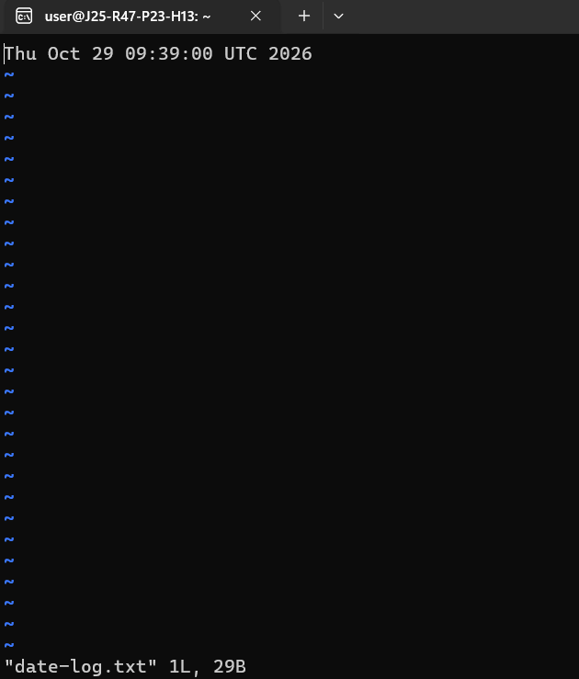

2. atrm — Remove a scheduled job
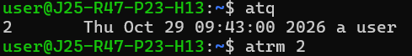
3. atq — List pending scheduled jobs
4. batch — Run a task when system load is low
5. cron — Background scheduling service
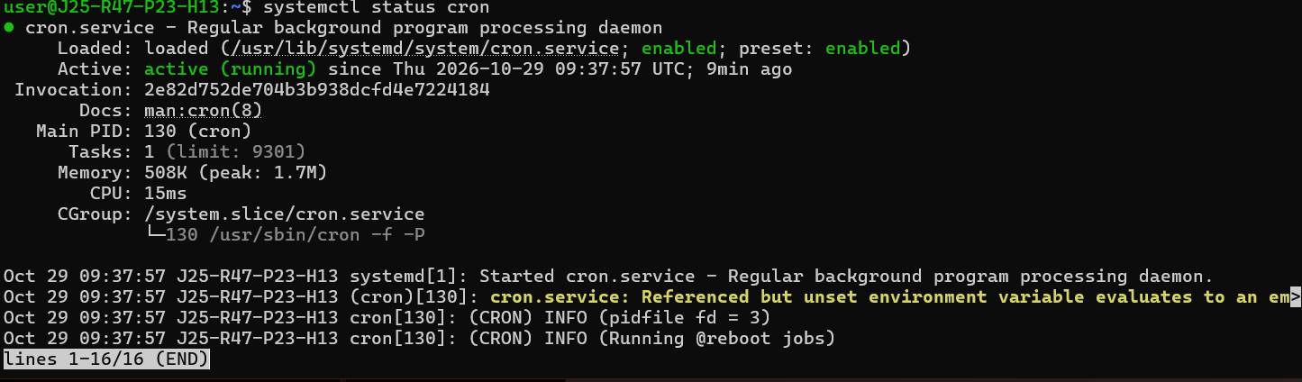
6. crontab — Schedule recurring tasks
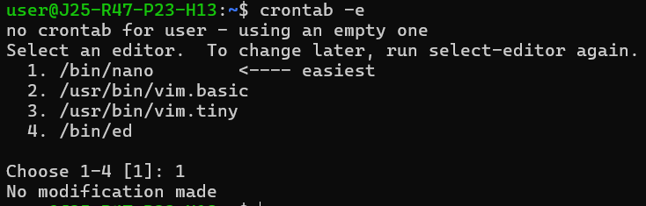
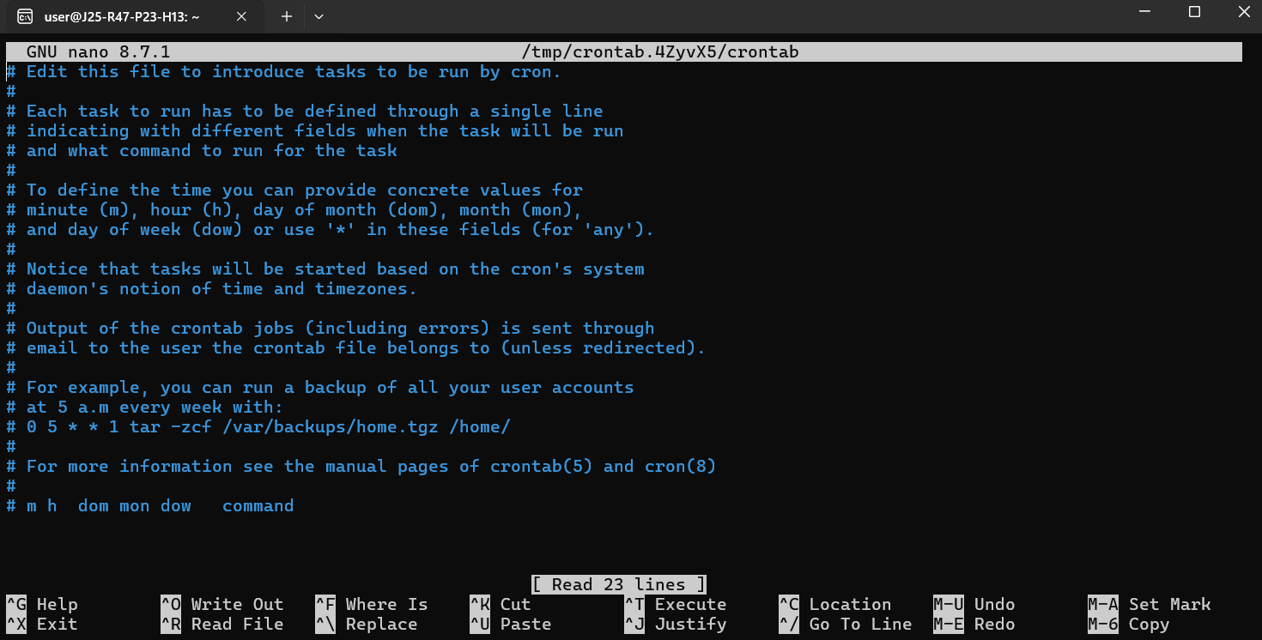
7. dump — Back up an ext2/ext3/ext4 filesystem
8. dumpe2fs — Display ext filesystem information

9. fdisk — Display partition information
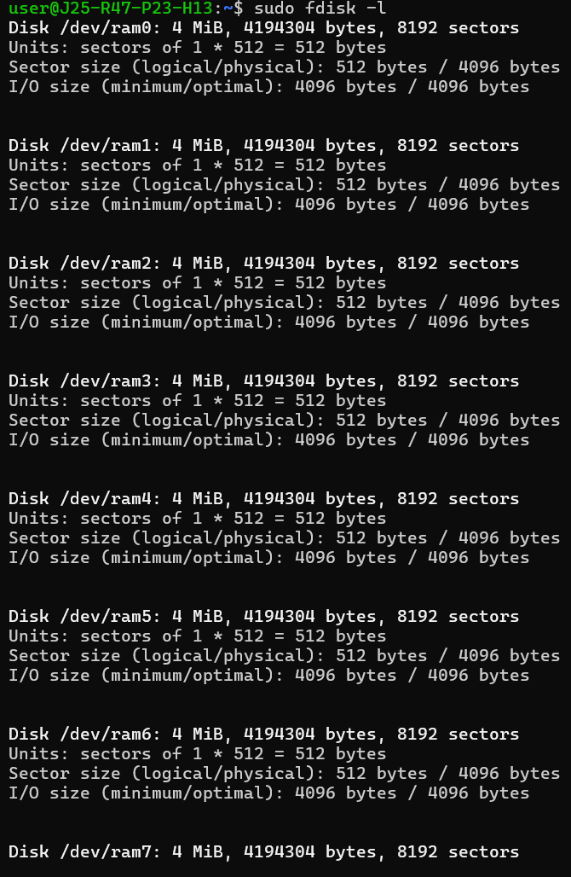
10, sync — Flush pending writes to storage
